Procedure to add a physical volume to a vfiler

In the example below an existing physical volume is being added to an empty vfiler: (quotas and exports had already been created). Instructions are also listed below how to create a dataset and add the physical volume to it, so it shows up in the NMC.

1. Run ADD commands from eg-nasapp-h17:
rsh eg-nasapp-h17-mgmt vfiler add ded-ecom-h0011 /vol/nv_cobaltmetadoc1p_n01ora1_nosnap
rsh eg-nasapp-h17-mgmt vfiler add ded-ecom-h0011 /vol/nv_cobaltmetadoc1p_s01ora1_snap
rsh eg-nasapp-h17-mgmt vfiler add ded-ecom-h0012 /vol/nv_cobaltmetadoc2p_n01ora1_nosnap
rsh eg-nasapp-h17-mgmt vfiler add ded-ecom-h0012 /vol/nv_cobaltmetadoc2p_s01ora1_snap

2.
From eg-nasapp-h17, EXPORT permissions:
vfiler run ded-ecom-h0011 exportfs –a
vfiler run ded-ecom-h0012 exportfs –a

3.
From eg-nasapp-e17, turn QUOTAS on:
vfiler run ded-ecom-h0011 quota on nv_cobaltmetadoc1p_n01ora1_nosnap
vfiler run ded-ecom-h0011 quota on nv_cobaltmetadoc1p_s01ora1_snap
vfiler run ded-ecom-h0012 quota on nv_cobaltmetadoc2p_n01ora1_nosnap
vfiler run ded-ecom-h0012 quota on nv_cobaltmetadoc2p_s01ora1_snap

4.
Turn on SNAP AUTODELETE:
rsh eg-nasapp-h17-mgmt “vfiler run ded-ecom-h0011 snap autodelete nv_cobaltmetadoc1p_s01ora1_snap trigger snap_reserve”
rsh eg-nasapp-h17-mgmt “vfiler run ded-ecom-h0011 snap autodelete nv_cobaltmetadoc1p_s01ora1_snap on”
rsh eg-nasapp-h17-mgmt “vfiler run ded-ecom-h0012 snap autodelete nv_cobaltmetadoc2p_s01ora1_snap trigger snap_reserve”
rsh eg-nasapp-h17-mgmt “vfiler run ded-ecom-h0012 snap autodelete nv_cobaltmetadoc2p_s01ora1_snap on”

5.
Configure SNAPSHOTS:
rsh eg-nasapp-h17-mgmt “vfiler run ded-ecom-h0011 snapvault snap sched nv_cobaltmetadoc1p_s01ora1_snap sv_nv_cobaltmetadoc1p_s01ora1_snap_s01oradata1 7@-“

rsh eg-nasapp-h17-mgmt “vfiler run ded-ecom-h0012 snapvault snap sched nv_cobaltmetadoc2p_s01ora1_snap sv_nv_cobaltmetadoc2p_s01ora1_snap_s01oradata1 7@-“

7.
Create and attach datasets: (there may be a delays in the NMC before the volumes appear)
A. Create a dataset for each volume, then attach the existing volume to the dataset
NMC | select Data in lower left | Datasets in upper left | Add | add volume name (use default time) add ppid to description field | drill down into filers and select the physical filer name | select provisioning policy (e.g. thick nosnap) | Highlight the resource pool (for your physical filer) and click “>” to add it to “resource pools in this node”. Note: do not touch the NFS and CIFS export settings, you can leave them at the default “OFF”. When you create a dataset that you plan to attach to an existing volume, you don't want to touch NFS or CIFS. The dataset will inherit those settings from the existing volume | click next | select your vfiler name (e.g. prod-ecom-h0001) | Make sure there are no warnings on the Preview Details page (note: “Data export protocol: will be “None”) | select “No, I will provision storage later”

B. Attach the existing volume to the dataset. There may be a delay in the volume showing up during the migration when you drill down under FILERS then your vfiler. This part is not crucial to the physical to vfiler portion of the migration so you can perform this task later: (it’s also one more step you won’t need to reverse if back-out is required.)
Datasets | select dataset Tip: click Resource pools then go back into Datasets so it re-populates so you can see the dataset if it doesn't appear (you’ll notice nothing is listed next to “Physical Resources” in the lower right at this point) | edit | physical resource | tie to volume (drill down from FILERS! – not directly to vfiler) drill down ALL THE WAY to the actually volume inside the vfiler (see bitmap below) | Make sure there are no warnings on the Preview Details page | finish | close the window

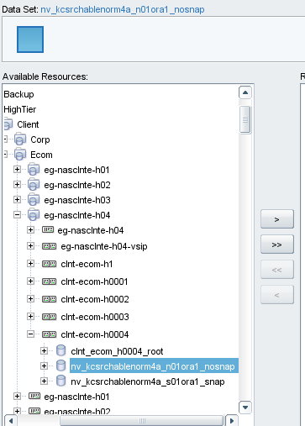

9.
Optional: (should not be necessary. To clear cache and force dns lookup)
vfiler run ded-ecom-h0011 exportfs -f
vfiler run ded-ecom-h0012 exportfs -f

Optional: (should not be necessary)
from eg-nasapp-h17 run exportfs –f

10.
Have Unix mount vfiler volumes.

